Viking Motorsports
Digital Dash
Project Proposal
January 28th, 2015

Sean Koppenhoffer, Rishal Dass
Jaime Rodriquez, Noah Erickson, Chad Thueson

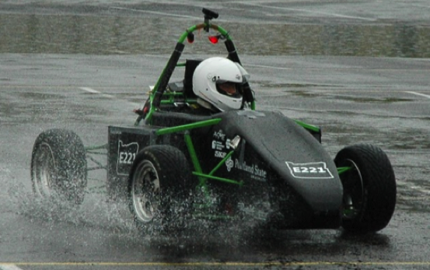

Table of Contents
Objective 3
Motivation 3
Description 3
Components 3
Mainboard 3
Microcontroller 3
CAN Transceiver 4
Power Supply 4
Voltage Regulator 4
Display 4
GUI Design 4
Enclosure 4
Location 5
Timeline 5
Glossary 5
References 5

Objective
The objective of this unit is to provide the operator of the Viking Motorsports Formula SAE electric vehicle with information about the vehicles operation. The information will be gathered from the onboard vehicle control unit (VCU), deciphered by a main processing unit and displayed on a liquid crystal display (LCD) mounted in the operators view. Mission critical information, such as warnings about battery management systems (BMS), insulation-monitoring devices (IMD) and system temperatures will be displayed on the digital dash.

Motivation
The Viking Motorsports team has both an internal combustion engine car and an electric car that they use to compete in Formula SAE competitions. With the addition of complex electrical systems in the electric car, the Viking Motorsports team wants to create a dashboard that goes beyond the standard race car dashboard. Such a dashboard will include a LCD screen instead of the traditional LEDs used. The digital dash will integrate with the vehicles systems to display relevant information to the driver and will look good doing so.
Another motivation for the digital dash is to lay a road map for future electric cars in Formula SAE that wish to include a more sophisticated dashboard in their design. It is the desire of the Viking Motorsports team to have the digital dash be open source so they can share it with other teams that show interest. Perhaps if enough teams adapt to a digital dash the product can evolve over time to support new features outside the scope proposed here.

Description
The complete package will be made up of a single enclosed unit. The unit will consist of a mainboard (comprised of a microcontroller and power supply), an LCD screen, and an enclosure. The complete unit will have an input that gathers data from the multiple CAN busses on the vehicle and an output that displays the information on the LCD. The digital dash system will be readable in sunlight, waterproof and robust against racecar conditions.

Components

Mainboard
The mainboard will be designed to house the microcontroller, power supply and other necessary components for their functionality. The final mainboard will be a printed circuit board.

Microcontroller
The microcontroller will be the brains of the digital dash. It will acquire messages sent across the CAN bus and decide what information is needed to be displayed on the dash. The microcontroller will connect to the CAN bus and the display. The ATSAM3X series of microcontrollers have been chosen as the microcontroller for the porject. The ATSAM3X is a 32-bit, 84-MHz microcontroller series that will operate quick enough to handle the messages being transmitted on the CAN bus. The ATSAM3X is also the microcontroller found in the Arduino Due, which is planned to be used on the electric vehicle. The microcontroller will be located on the mainboard.

CAN Transceiver
The CAN transceiver that will be used is the MCP2551. The electric vehicle has two CAN busses, one from the vehicle control unit (VCU) and one from the battery management system (BMS). Because two seperate CAN busses exist, two MCP2551s must be used – one for each CAN controller on the microcontroller. The MCP2551 comes in either a through hole or surface mount package.

Power Supply
The power supply will deliver power to the display and the microcontroller. The power supply will draw power from the 12V rail that is supplying the VCU and will be stepped down through voltage regulators to 5V. There will be plenty of bypass capacitors in order to reduce voltage spikes seen across the components. The power supply will be located on the mainboard.

Voltage Regulator
The voltage regulator that will be used is an LM7805 or a variation of it. The voltage regulator has an input that ranges from a steady 6-12V and an output of 5V. The device comes in either a through hole or surface mount package. The voltage regulator will be located on the mainboard.

Display
The display will visually output the information that is passed to it from the microcontroller. It will be capable of displaying color and will be visible in direct sunlight. The display must be large enough to see from the drivers viewpoint but also small enough to fit on the dash. The display will be a 4D Systems’ uLCD-35DT-AR. A polarizing shield will be placed over the screen to ensure that it can be read in sunlight.

GUI Design
The graphical user interface (GUI) will be the selling point of the digital dashboard that the customer will interact with and remember. It will be the visual output on the display and will be as simple as possible. The GUI will use a black background to minimize clutter and will have three large icons indicating BMS status, IMD status, and system temperatures. The battery voltage will be displayed in a simple manner with blocks dedicated to percentages of battery life.

Enclosure
The entire system will be a self-contained unit in the form of small black box. The enclosure will be constructed of a robust material. The screen will be visible on the front. The back of the digital dash unit will have a plug for power and the CAN bus. The unit will be able to survive the 2-minute rain test that the Viking Motorsports team must stress the car with according to the Formula SAE rules. That is, the device must adhere to IP65.

Location
The digital dash will be designed for mounting on the right hand portion of the Viking Motorsports Formula SAE electric car (if space permits). The unit will be positioned in the dash for an optimal viewing angle for the driver.

Timeline
The first prototype iteration of the digital dash will be completed in early March to allow the Viking Motorsports team to familiarize themselves with the functionality and usage of the unit. Based off the feedback from the electric vehicles’ driver some changes may be made and features may be implemented for a second final iteration of the digital dash, which will be complete no later than the end of May.

Glossary

BMS – Battery Management System
CAN – Controller Area Network
GUI – Graphical User Interface
IMD – Insulation Monitoring Device
IP – Ingress Protection
LCD – Liquid Crystal Display
SAE – Society of Automotive Engineers
VCU – Vehicle Control Unit

References
Digital Dash Github Repository
https://github.com/noahterickson/DigitalDash/wiki

Viking Motorsports Webpage
http://vms.groups.pdx.edu/

